Task 4: Create a basic keylogger program that records and logs keystrokes. Focus on logging the key pressed and saving them to a file.

Input code:

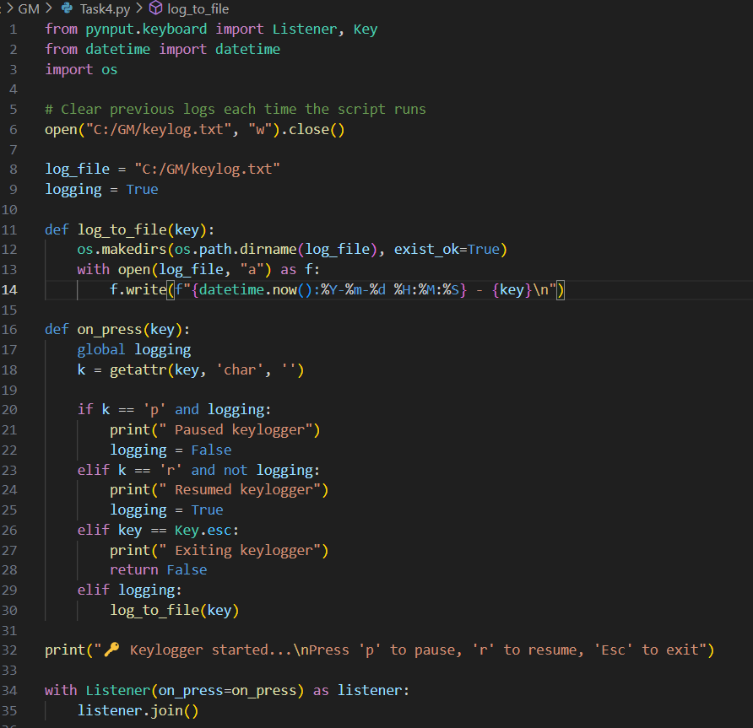

Output:

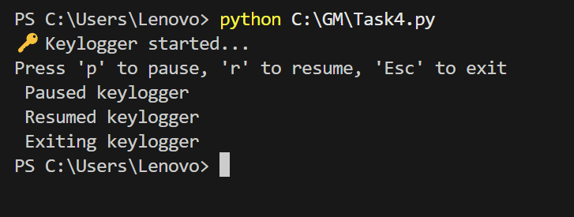

How to run the code:

1. Install pynput that is suitable and matches the current version of python .
2. Once the code is saved , open the terminal and type python The path of python file and press enter
3. If the script runs successfully, it will show a message like:

Keylogger started...

Press 'p' to pause, 'r' to resume, 'Esc' to exit

1. Leave this Command Prompt window or terminal open while the script runs.
2. Open any other program like Notepad, Word, or even a web browser.\\
3. Start typing anything as you normally would.
4. Your keystrokes will be recorded and saved in the file (here keylog.txt).
5. Press the p key in the Command Prompt or any terminal to pause logging.
6. Press the r key in the Command Prompt or any terminal to resume logging.
7. Press the Esc key in the Command Prompt or terminal to stop the script and close the (keylogger).
8. **Step 6: View the Keylog File**

* Open File Explorer.
* Navigate to the folder where you saved the script, such as C:\GM.
* Look for a file named keylog.txt.
* Double-click on keylog.txt to open it.
* You will see a list of all the keys you typed, along with the time each one was recorded like:

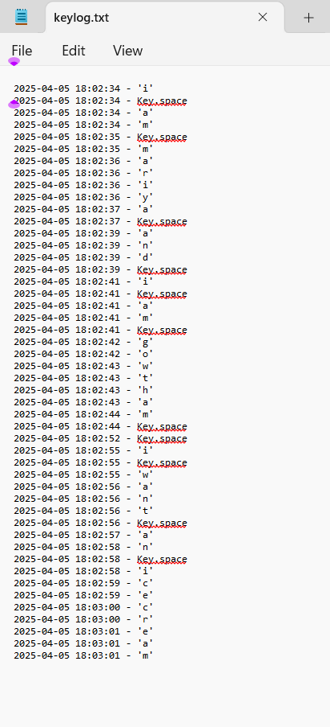

1. Re-run when needed , you do not need to delete the (keylog)or the text file each time. The script will continue adding new data to it.
2. Only typing in other applications will be recorded. Typing in the Command Prompt or the terminal will not be recorded.

A summary of the working :

This Python code is a simple keylogger that records every key you press on your keyboard and saves it into a file called keylog.txt along with a timestamp. When you run the code, it starts listening in the background, logging only the keys you type. It includes basic controls: pressing p in the terminal pauses the logging, r resumes it, and pressing the Esc key stops the program. The log file keeps collecting typed keys unless you delete or clear it. This program is useful for basic activity tracking or learning purposes, but should always be used responsibly and legally.